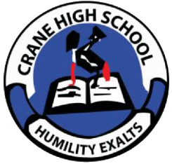 **CRANE HIGH SCHOOL**

**P.O BOX 100, SOROTI**

**Email:** [**cranehssoroti@gmail.com**](mailto:cranehssoroti@gmail.com)

**Tel: 0774005364, 0782140180**

**3rd. Jan. 2024**

**VACANCY**

Crane High School Soroti is seeking to recruit suitably qualified persons to fill the following vacant positions

**1. HEAD TEACHER** 01 Vacancy

* Should be registered with the MOEs
* Teaching experience at a graduate level of not less than 5 years.
* Administrative experience of at least 3 years
* Post Graduate Diploma or Masters Degree in Education Administration and Management is an added advantage

**2**. **TEACHER ICT** 01 Registered graduate

**3. TEACHER PHY/MTC** 01 Registered graduate

**4. TEACHER BIO/CHEM** 01 Registered graduate

**5. TEACHER GEO/DIV** 01 Registered graduate

**6. BURSAR**

* Should possess a Diploma in Business Studies or Diploma in Accounting and Finance
* Competent in ICT
* Well versed with modern Accounting packages
* Minimum of 3 working years in a relevant field.

**NB.** Hand written application or soft copy and accompanying CVS should be delivered to Crane High School or sent on whatsapp to the above contacts

Deadline for receiving applications is 12th -Jan-2024 at 4: 00pm

**Management**